Toskánsko 13.9. – 20.9.2008
VILLA LOUISA
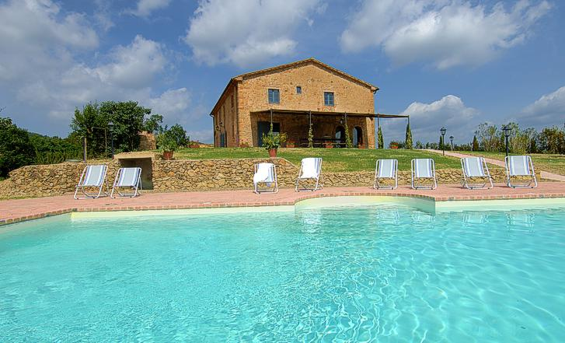

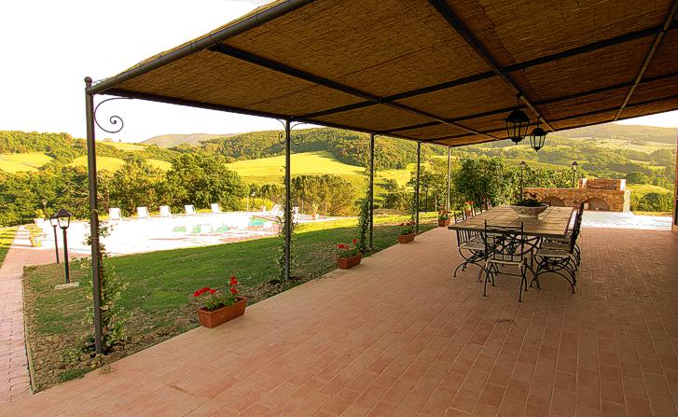

- Luxusní toskánská vila u městečka Cecina vzdálená jen cca. 10 km od písečných pláží středozemního moře.
- Velkorysé prostory pro 12 osob (380 m2 obytné plochy).
- Velká zastřešená terasa s překrásným výhledem.
- Vila je obklopena 700 hektary soukromého pozemku.
- Všechny pokoje mají klimatizaci (za příplatek) a velká okna s výhledem do dálek Toskánska.
- SAT-TV und Stereo-CD přehrávač, rychlý internet (za poplatek), myčka a pračka jsou v domě.
- Na přání je k dispozici kuchař(ka) příp. uklizečka.

Vzdálenosti od vily (vždy jedna cesta).

Cecina (moře - jsou tam dlouhé písečné pláže) 10 km.
Volterra (staré etruské město) 29 km.
Siena (kulturní dědictví UNESCO) 79 km.
San Gimignano (středověké město věží – kulturní dědictví UNESCO) 57 km.
Piombino po pobřeží (trajekt na ostrov Elba) 51 km.
Pisa (kulturní dědictví UNESCO) 69 km
Firenze (kulturní dědictví UNESCO) 120 km
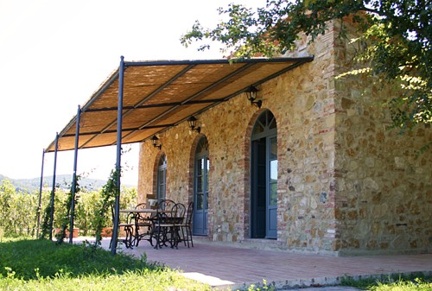

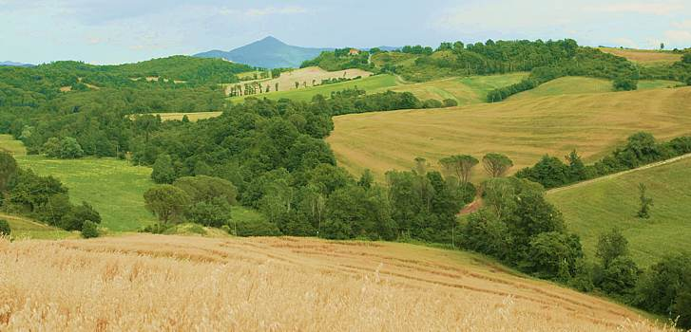

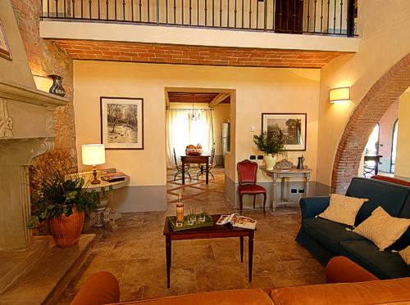

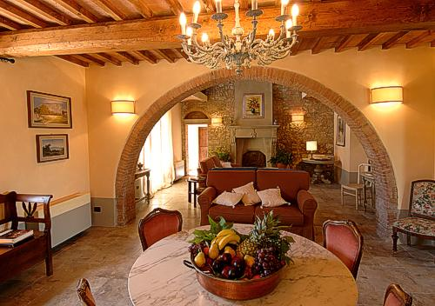

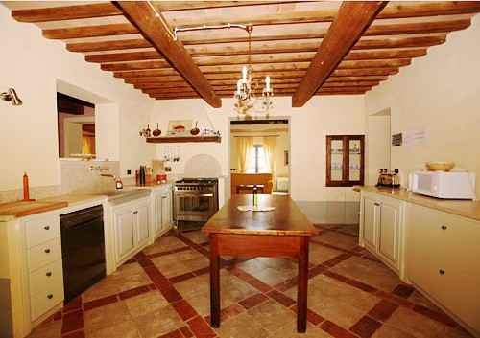

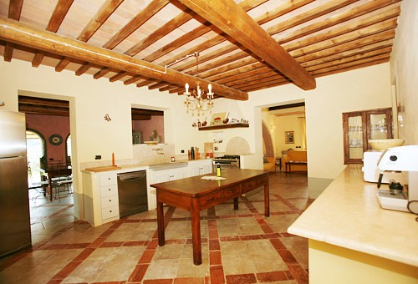

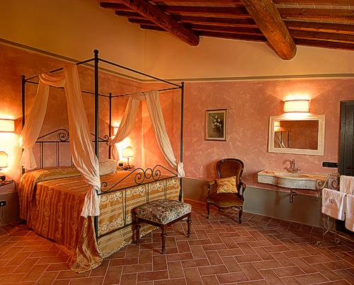

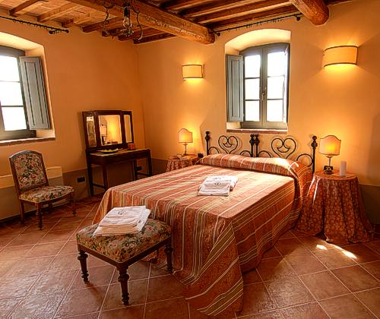

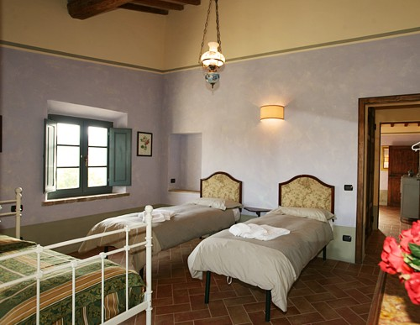

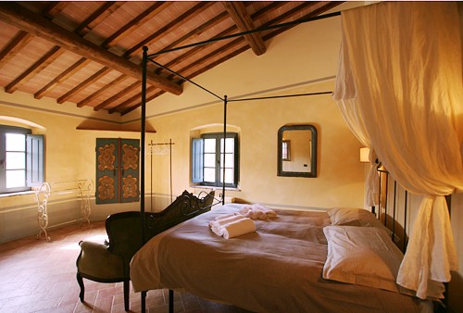

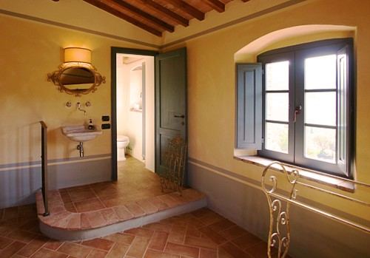

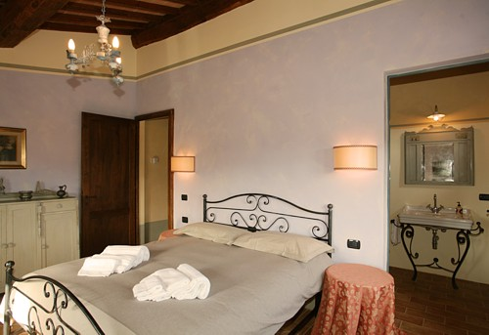

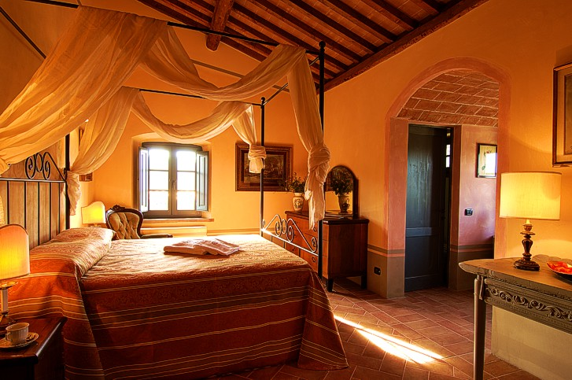

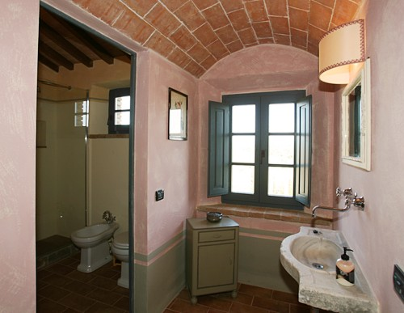

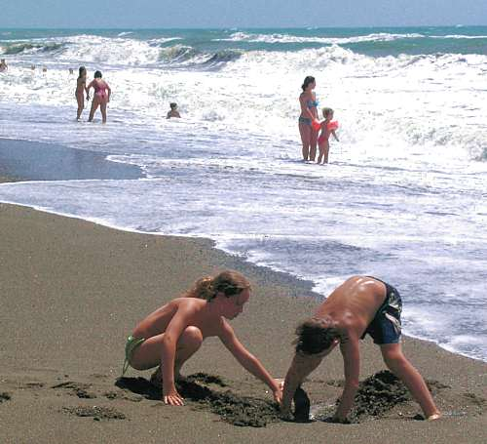

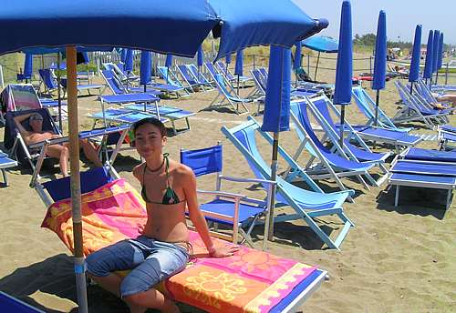

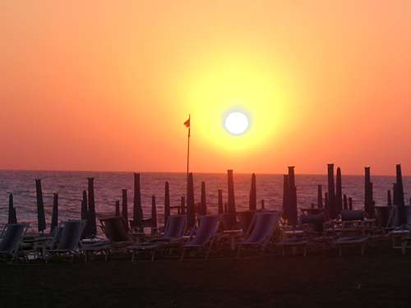

Od 13.9. do 20.9.2008 se uskuteční naše cesta do Toskánska.
30. června jsem objednal přes agenturu Tuscany Prime LTDA vilu Louisa pro kapacitu max. 12 osob.
http://www.villen-toskana.de/more_photos,idhouse,528.html
Zálohu na vilu € 1 535,-- jsem 8. července zaplatil.
Cena: € 3.600,- / týden (vyjednal jsem ještě slevu € 200,- z € 3.800,-)
€ 200,- povlečení, ručníky, voda, el.proud a úklid
€ 30,- administrativní poplatek
€ 3.830,- celkem

Při 12 osobách € 319,66 / osobu / týden
Kč 8.000,- / osobu / týden (při 1 € = Kč 25,-)
Kč 1.143,- / osobu / den

K tomu přibudou ještě nějaké další poplatky, např. klimatizace pokojů, pokud to vůbec bude třeba.
Dále je u recepce internet point, za který se ale též platí – 10€/hod. nebo 15€/3hod.
Dle posledních informací nestojí internet nic, pokud se připojíte vlastním notebookem.
Doufám, že bude dosah až k vile Louisa.
Při příjezdu je třeba dále předat v hotovosti kauci € 1.000,--, která se při odjezdu vrací.
Já jí zaplatím a použiji na doplatek nájemného.

Pošlete mi zatím jako zálohu Kč 4 000,- / osobu na účet
Pošlete mi nyní doplatek dalších Kč 4 000,- / osobu na můj účet

Antonin Stepanek
UnicreditBank
č.účtu: 7347641001
SWIFT: BACX CZ PP
Kód banky: 2700

Vila je velmi luxusní, každý pokoj (dvojlůžka) má vlastní koupelnu.
Poloha je též velmi dobrá v srdci Toskánska.

místo: 56040 Casale Marittimo - Ricrio (Pi),
v blízkosti je vesnička Guardistallo,

Příjezd ze severu:
Dálnice A12 až k výjezdu ROSIGNANO MARITTIMA. Potom na na výpadovou silnici směr ROMA a dále k výjezdu CECINA CENTRO. Následujte silniční ukazatele CASALE MARITTIMA. Krátce po CASALE MARITTIMA (před GUARDISTALLO) se držte vpravo směr CANNETO-PONTEGINORI a pak po cca. 1 km se držte vlevo směr VOLTERRA. Těsně poté uvidíte vpravo velkou žluto-oranžovou vilu se špičatými obloukovými okny, je to VILLA RICRIO. Za ní se nachází recepce, kde Vás bude očekávat majitelka PAULA VINCENZI a ukáže Vám dům.

Kdo má GPS, přesná adresa je: Via della Camminata, 2 bis – Guardistallo – (Pisa)

Pozor, silnice Via della Camminata 2 je 25 km dlouhá.

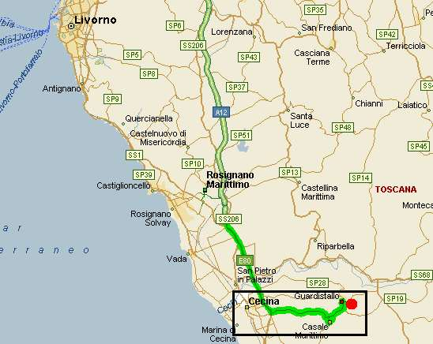

GPS: nord: 43° 17' 58
GPS: ost: 10° 39' 13
recepce: u vily Ricrio, vedle silnice Via della Camminata
villa Louisa je vzdálená cca. 1 km
jméno: Paola Vincenzi
telefon +39 02 27207353
mobil 1: +39 34 84100897
mobil 2: +39 34 78322843
e-mail: paola@vip-srl.it
příjezd: sobota 13.9.2008 od 16:00 hod.

Vzdálenost z Prahy je přes Brenner cca. 1190 km.
Praha-Rozvadov-Regensburg-München-Innsbruck-Brennerský průsmyk-Verona-Modena-Bologna-Firenze-Guardistallo.

Mýto: Rakousko 10 denní Vignette € 7,70 + Brennerská dálnice € 8,--
Itálie Brennero – Rosignano cca. € 42,- (jedna cesta)
Celkem tam a zpět € 115,-- / auto

Alternativně přes Bregenz cca. 1230 km.
Praha-Rozvadov-Regensburg-München-Bregenz-Chur-San Bernardino-Lugano-Milano-Parma-Pisa-Guardistallo.

Mýto: Rakousko pokud nepojedeme po dálnici do hor, tak není Vignette třeba
(Bregenz – St.Margrethen_CH není dálnice)
Švýcarsko roční Vignette CHF 40,-- = cca. € 25,--
Itálie Como – Rosignano cca. € 30,- (jedna cesta)
Celkem tam a zpět € 85,-- / auto

Program: tentokrát zcela individuální,
- koupání u moře,
- cyklotúry,
- kulturní – návštěva světoznámých měst
- lenošení u bazénu
- toskánské večeře na terase
vše rozhodneme spontánně podle počasí a nálady na místě
Rozšířený program: odjezd z Prahy ve čtvrtek 11.9.2008 do Bregenzu (přibližně polovina cesty).

Účastníci: Radana + Toni
Jája + Honza Brč
Jitka + Mirek Špačkovi
Irena + Lojza PP
Jirka + Rajče
Zorka + Petr Krejčí pojedou přímo do Itálie.

Ubytování jsem zajistil v Pensiónu Furka v horské vesnici Damüls v Bregenzerwaldu ve výšce 1500 m n.m. od 11.9. – 13.9.2008 ve dvoulůžkových pokojích.
Cena je € 25,-/osobu a noc včetně snídaně.
Platí se na místě.
Je to levnější než v Bregenzu, kde by to stálo € 40,- až 50,- / osobu a den.
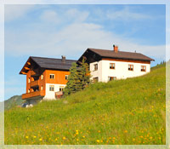

Kontakt:
Familie Dietmar Bischof
Oberdamuels 183
6884 Damuels, Österreich
Tel.: +43(5510)255
Tel.: +43(664)4652924
Fax: +43(5510)2554
E-Mail: info@hausfurka.at
WWW: http://www.hausfurka.at

Sejdeme se u mě v Bregenzu ve čtvrtek odpoledne, bude káva a já Vám vysvětlím, jak se tam dostanete.
Pokud by jste přijeli již kolem poledne, tak bychom mohli něco v Bregenzu podniknout, příp. vylézt na Pfänder.

Vezměte si pohorky a oblečení do hor.

V pátek 12.9. buď výšlap po hřebenech v okolí Damülsu, cca. 5-6 hod. ve výšce 1500 až 2100 m n.m.
Je tam sice riziko špatného počasí, ale nechme se překvapit, doufám, že se nebudeme koulovat…
V sobotu 13.9. přes Furka-Pass, Laterns, Rankweil a přes Švýcarsko do Toskánska.
Návrat 20.9.2008 do Bregenzu, příp. přenocování v Bregenzu (dejte mi vědět, kdo má zájem) a 21.9.2008 dále do Prahy.

Toni 4.9.2008

V příloze jsou podmínky pobytu ve vile Louisa.
Důležité body: - není tam pitná voda!
-v poolu se můžeme koupat i večer, ale jen na vlastní nebezpečí.
- kuchař na večeři bude stát € 15,-/osobu + potraviny, alespoň jednou bychom to měli
zkusit
- dále jsou v blízkém okolí typické restaurace, ale i supermarkety a obchody
- pro přihlášení vytvořím tabulku, k tomu potřebuji Vaše osobní údaje:
- příjmení a jméno
- místo a datum narození
- adresa bydliště
- země a směrovací číslo
- druh a číslo cestovního dokumentu, datum vystavení, vystaveno kým.

Dále přikládám ještě mojí e-mailovou korespondenci.

T e n u t a R i c r i o
T o s c a n a - I t a l i a

Please read the following rules and useful information:
- Regulations of the house and the swimming pool

- Road indications

- Information about shopping, etc…

- Police registration on your arrival

1) REGULATIONS: The Society wishes to inform you that:
ACCOMODATIONS:
  - Access forbidden to animals without prior permission
  - No tents, caravans or camper vans allowed
  - The lighting of Villa Ricrio’s fire places is NOT allowed
  - Dogs must be kept on a leash
  - More people than authorised by the Society are not permitted to use the villa.
  - No un-authorised extra beds allowed
  - No parties allowed without prior permission
  - DO NOT use flammable material/liquids to light fires
  - Never leave fires un-attended
  - During the weekend AND at the end of the stay RUBBISH must be thrown away BY THE CLIENT into the appropriate bins situated along the main roads. Please DO NOT PUT rubbish outside the house at night time due to wild animals in the vicinity
  - DO NOT drink the tap water
  - DO NOT WASTE WATER PLEASE as Tuscany has serious water problems

SWIMMING POOL: FOR THE EXCLUSIVE USE OF GUESTS ( REGIONAL LAW. N. 8/2006) :
  - There is no life guard for the swimming pool
  - The pool is not fenced
  - Non-swimmers are prohibited from using the pool
  - Swimming pool size: 10 x 5 meters, depth 150 centimeters
  - No diving allowed or running around the pool area
  - Children under 14 MUST be accompanied by an adult while using the pool
  - No animals allowed
  - It is forbidden to use pool if suffering from a contagious illness
  - No swimming allowed while the pool cleaner is working
  - No electrical appliances allowed in or near the pool
  - No swimming during storms or bad weather
  - No stones or sharp objects are to be put in the swimming pool
  - It is prohibited to touch technical parts of the pool or to put products into the water
  - No swimming after meals
  - The swimming pool and tap water is not drinkable
  - DO NOT use the swimming pool from 8 pm to 9 am

The Society wishes to inform the client that there is no life guard for the swimming pool and that the use of the swimming pool, mountain bikes, barbecue, fire places, etc.. involve risks and dangers that the client, signing this document, acknowledges and takes full responsibility on behalf of himself and the other members of the group exonerating the Society of any responsibility. The client guarantees to respect the above mentioned regulations. We wish to inform clients that even if they are absent at the time, property employees are authorised to enter the premises where repairs or maintenance are required or in exceptional circumstances. The client signing this document understands and fully accepts ALL of the above mentioned rules and conditions on behalf of himself and the other members of the group. IN THE CASE OF AN EMERGENCY, CALL 118 and then inform the society immediately.

2) ROAD INDICATIONS:
From the North:
Highway A12 (Livorno-Rosignano), at the end of it (tollgate of Rosignano) follow the sign for Roma (left freeway) and exit at Cecina centro.
Once off the freeway follow signs for Guardistallo, its uphill and very windy. At the T junction of Guardistallo turn right following the signs for the Casale Marittimo direction but the turn is before the town so pay attention to the road signs. Going towards Casale Marittimo, there is a turn to your left 1 km after leaving Guardistallo where the signs read to Bibbona, Volterra, Canneto, Ponteginori. Follow this road (strada Provinciale dei tre Comune direzione Pozzatelli) keeping always to your left for a few kilometers. On your right you will see a big yellow Villa that is Villa Ricrio, continue 300meters and turn right at the gravel driveway that will lead you to Reception: The exact address is: Via della Camminata, 2 A – 56040 Guardistallo – (Pisa).
From the South:
From Rome follow the Aurelia Road in the direction of Civitavecchia, then Grosseto and then for Livorno . Exit at La California then follow the signs for Bibbona. DO NOT turn right to enter Bibbona, but remain on the same road coming from La California. DO NOT turn left to go up to Casale Marittima, but continue straight ahead following the Volterra road signs. After about 3 km you will see on the right a big yellow Villa that is Villa Ricrio. Continue for another 300 meters and turn right going up the gravel driveway to Reception.
From Florence:
Take the freeway FI-PI-LI direction Livorno. Before Livorno there are indications to Rosignano Marittimo highway 12. Once at Rosignano follow the same indications mentioned in “directions from the North”

GPS:
N 43° 17’ 58
E 10° 39’ 13
PS: We suggest that you follow our written indications rather than use any GPS from Cecina because Via della Camminata is 25 kms long and you will arrive opposite side.

3) GENERAL INFORMATION
Shopping:
The large Supermarkets are just a few kilometres away in Cecina, One of the several is the supermarket Conad on Aurelia Road which is open daily from 8 am to 8 pm including Saturday s and Sundays.
Close to your Villa there are two villages: Guardistallo and Casale Marittimo where there are little shops and small supermarkets best used for those forgotten items and daily fresh bread.
Street Markets are: Sunday mornings at Cecina-Mare and Tuesday mornings in Cecina

IN CASE YOU DESIRE TO FIND FRIDGE AND CUPBOARDS ALREADY STOCKED AT YOUR VILLA FOR YOUR ARRIVAL PLEASE LET US KNOW SENDING US A SHORT SHOPPING LIST OF THE REQUIRED ITEMS AT LEAST 10 days BEFORE ARRIVAL EITHER by mail or by fax at +39-0586-652894
Meals:
Upon request, a cook is could be available in the area for the delivery and preparation of breakfast, lunch and dinner. She prepares the food beforehand and will deliver it to you villa at the pre-established time. For food that cannot be prepare beforehand, such as pasta or risotto, she will cook it at your villa, then leave you to your privacy. Cooking classes could be organized upon request.
IN CASE YOU WISH TO FIND DINNER READY FOR YOUR ARRIVAL DAY WE NEED TO BE TOLD AT LEAST 1 WEEK BEFORE.
IN JULY AND AUGUST OR IN CASE BIG GROUPS IT’S ALWAYS BETTER TO MAKE A RESTAURANT RESERVATION AT LEAST 15 DAYS BEFORE.
Wine Tours:
During your stay if you are interested in wine tours we recommend that you contact directly Miss Cristina Galliti at cristina@docvinoandc.it ; www.docvinoandc.it
You could also contact wineries directly by looking at the website: www.lastradadelvino.com
Beaches and Islands:
The nearest beach is Cecina Mare however we suggest either Marina di Bibbona or the “white beaches” of Rosignano (Vada).
Close to the coast it’s possible to visit the islands that make up the “Archipelago toscano”. The most well known and easiest to visit is Elba Island where the ferries leave from Piombino.
TV:
each villa is equipped with satellite television and decoder. You are able to use your satellite card
Wi-Fi connection and internet point:
available next door to the reception area
WE ARE ABLE TO GIVE YOU INFORMATION ABOUT MANY TOPICS…
TENNIS, MINI BUS RENTING, FISHING BOAT OUTINGS, ITALIAN LESSONS , YOGA/MASSAGE SESSIONS, HORSE RIDING LESSONS OR WALKS, ETC… JUST ASK AND WE WILL TRY TO FIND THE ANSWER FOR YOU

4)POLICE REGISTRATION
CHECK-IN:
It will be at the reception. Normal check-in time is between 4.30 pm to 7 pm. Sometimes it’s possible to arrive earlier or later with previous arrangements. At the check-in we will ask you the payment of the security deposit that must be given in Euro cash, the eventual payment of the balance, and the signature of the document containing rules and law release you have at point 1).
The law obliges us to register all guests. It would be helpful for us to have in advance details of the guests that will be holidaying at the villa. Please would you be so kind as to complete the information asked for that follows.
Surname and name of each guest
Date and place of birth of each guest
Address
Country of citizenship
Type and number of document, date of issue and issuing authority.
If you are able to e-mail me this information in advance it enables your check-in time to be quicker.
Please inform me about your group and your arrival plan times.
CHECK-OUT:
It will be Saturday at 9.30 am. A property employee will arrive at your villa around 9 am on your departure morning to check the premises prior to the return of the security deposit. It’s possible to leave earlier with pre-arrangements
USEFULL NUMBERS:
Reception tel: +39-0586-652329
receptionist cell. Phone: Nicole +39-340-8698536
fax: +39-0586-652894
Paola cell. Phone: +39 348 4100897
I'm at your complete disposition for any further information or enquiries.
D.ssa Paola Vincenzi
Tenuta Ricrio

Korespondence:

From: Toni Stepanek / steco data [mailto:stepanek@stecodata.at]
Sent: Tuesday, September 02, 2008 4:06 PM
To: 'Lidia Vincenzi'
Subject: RE: Villa Louisa Tuscany 13.9-20.9.2008

Dear Lidia,

thank you again for your informations.

Ad 1)
We will arrange everything after our arrival.

Ad 2)
We are all adults, good swimmer, therefore we accept the risk.

Ad 3)
That's fine.

Ad 4)
Perfect!

Ad 5)
Ok!

Due to your informations the tap water is not drinkable. Is that right? Must we buy the water from shops?

Thank you for you offer, but for sunday we dont need food, as we bring it along with us.
We will arrive with six cars and are therefore mobile.

Our group is: BBCC / Prague / Czech Republic

www.bbcc.cz

The group exists since 1997. We do a lot of travelling. We have already been in Austria, Switzerland, France, Norway, Corsica, Sardinia, Irland and many more countries.

This time we like to get to know the wonderful Tuscany. Before the arrival at villa Lousia we will stay a couple of days in the Austrian alps, near Bregenz, where I live.

We are looking forward discovering the Tuscany.

Toni Stepanek

From: Lidia Vincenzi [mailto:lidia@vinpe.it]
Sent: Tuesday, September 02, 2008 10:26 AM
To: stepanek@stecodata.at
Subject: R: Villa Louisa Tuscany 13.9-20.9.2008
Dear Toni, I’m Lidia, Paola’s sister.
We wait for you and your group soon!
To answer your requests:
1) Dinner
The dinner costs € 15 per person plus the refund of the shopping for all the ingredients needed to prepare dinner, plus also the beverages that you prefer (wine/beer/water/soft drinks etc…)
We can propose you a typical Tuscan Menu that is:
- Typical Tuscany starters like “Bruschetta (a slice of bread cover with oil garlic basil and Tomato) – tuscan patè – raw ham etc…
- Pasta named “Pappardelle al Cinghiale” that is a kind of pasta with a sauce made like Bolognese sauce but with wild pig meat instead of pork
- Mixed roasted meat (wild pig – pork – chicken etc…) with potatoes or salade (this is very good!)
- for dessert the best I think is the “Tiramisù” that you surely already know.
Let me know if you like it, but if you don’t need this for Saturday, like you told us, you can change it directly on place with the receptionist employee
2) Pool
The pool will not be “fisically closed” we recommend to not swim during the night because maybe some accident can occur (especially if the clients have children…you know that after dinner is dangerous to go in the water because of the digestion and the dark…)…but if you want to use it at your own risk is not a problem for us…so I think that the problem is solved.
3) Wine tour
Yes it’s possible to join a wine tour, you can find all the informations and book the tour directly at the reception of Villa Louisa.
4) Laptops
The internet connection it’s free! It work for sure at the reception…some clients were able to use their laptops also in Villa Louisa (also because it’s very close to reception) it depends by your laptop wireless connection, the only thing that you have to do is to fisically go in the reception before use internet to let the employee open the line.
5) Mountain bike maps
You can find some maps at the reception, I’m not sure if this maps specify “mountain bike side roads”…otherwise you can find maps on the internet or ask to the receptionist to find that for you.
I hope I answered to all you requests, please let me just know if you need some food shopping (without dinner) for the fist day in the house (like water – milk – juice etc…) or some other particular requests.
Thanks again and Villa Louisa employees are waiting for your group!
Lidia Vincenzi

Da: Toni Stepanek / steco data [mailto:stepanek@stecodata.at]
Inviato: martedì 2 settembre 2008 08.52
A: lidia@vinpe.it
Oggetto: FW: Villa Louisa Tuscany 13.9-20.9.2008
----- The following is an automated response
----- to your message generated on behalf of paola@vip-srl.it

I'm unavailable from 31st august to 16th september 2008. I will answer to your mail the 16th.
In case you need to send document details or shopping list or else... here you are the fax number: +39-0586-652894.
In case of need, please contact my sister Lidia at lidia@vinpe.it or by phone at +39-3483917068.

Reception number: +39-0586-652329

Regards,
Paola Vincenzi

Tenuta Ricrio
Agriturismo Valdicecina

From: Toni Stepanek / steco data [mailto:stepanek@stecodata.at]
Sent: Monday, September 01, 2008 2:30 PM
To: 'paola@vip-srl.it'
Subject: RE: Villa Louisa Tuscany
Dear Nicole,

Thank you very much for your information, I will forward it to all participants of our group. We are a group from Prague/Czech Republic (10-12 people). We mainly want to get to know Tuscany by Mountain bikes. Therefore we will bring the bikes with us from Prague.

We are really interested to order one or more typical Tuscan dinners in the Villla Louisa. Please let us know how much the cook and the meal cost. We would be pleased if you could also make a concrete menu proposal for the dinner.

For saturday, however, we dont want to order a dinner, as we are not sure when we will exactly arrive at the villa.

In your informations I read that the pool is closed in the evenings. Therefore I wanted to ask, if it is possible to make an exception for our villa? We plan to do a lot of mountainbike tours and therefore we will return most of the time in the evening, but we would really like to use the pool afterwards. I would be really thankful if you could solve this problem for me.

We possibly want to join a vinetour, is there anyone you can recommend?

Is there any possibility to use also internet on own laptops at the Villa Louisa or only at the reception? How much does it cost?

Is there any map for side roads (not main roads) for mountain biking.

Thanks a lot and please let me know as soon as possible.

Best regards

Antonin Stepanek
Wellenau 3
6900 Bregenz/Austria

+43 676 4005838 - AUT
+420 603 180880 - CZ

From: paola@vip-srl.it [mailto:paola@vip-srl.it]
Sent: Saturday, August 30, 2008 6:32 PM
To: stepanek@stecodata.at
Cc: paola@vip-srl.it
Subject: Villa Louisa Tuscany
Saturday 30.08.08
Dear Mr Stepanek,
My name is Nicole and I work in reception for Paola at the Tenuta Ricrio. I have noted that you have requested a meal prepared for you which is not at all a problem, however I need to know when it is for. If you require the dinner for the Saturday night of your arrival then it is important that you let me know by e-mail as soon as possible otherwise you will find nothing prepared.
If it will be for a night during the week after your arrival then you can let us know once you are here and settled in your Villa. It is enough a days notice so that the cook can buy the ingredients.

Looking forward to having you with us.
Best regards
Nicole
Reception
paola@vip-srl.it
HELLO MR STEPANEK I’M MORENA I WORK IN VILLA RICRIO RECEPTION.
THANK YOU FOR CHOOSING TO STAY WITH US .
I ATTACH TO THIS EMAIL IMPORTANT INFORMATION ABOUT US. PLEASE READ IT AND PASS ON TO YOUR GUESTS.
WE ARE AT YOUR SERVICE FOR ANY FURTHER INFORMATION.
….. IN REPLY TO YOUR WINE TASTING TOUR REQUEST, PLEASE CONTACT MAURIZIO AT THE FOLLOWING EMAIL ADDRESS INFO@TUSCANYTASTETOUR.COM TEL.+393476589132 +390586631706 WWW.TUSCANYTASTETOUR.COM

